NAME: The Australian Constitution
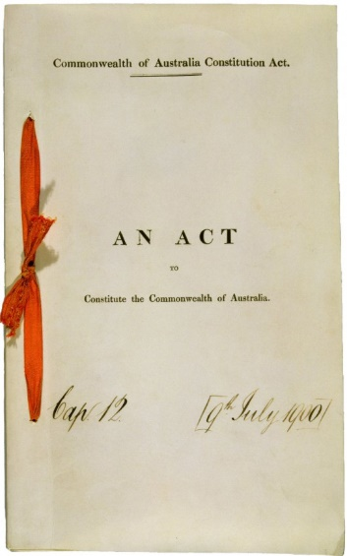
What is a constitution?
A national constitution is a set of rules for governing a country. Such rules may be based on tradition (unwritten) or may be written down in the form of a law or number of laws. In some countries laws forming the constitution are ordinary laws which can be changed just like any other law, but in most countries the laws forming the constitution have a special status.
The Constitution of Australia has a special status-it cannot be changed in the same way as other laws can be changed and it is a supreme law, that is, it overrides other laws.

How was the Australian Constitution created?
Before 1901 the present Australian States were separate colonies of the then British Empire. When the colonies decided to join together in a federation, representatives from each colony were elected to attend meetings (called constitutional conventions) to draw up a constitution for the new nation. The draft constitution was later approved by a vote of the people in referendums held in each colony.
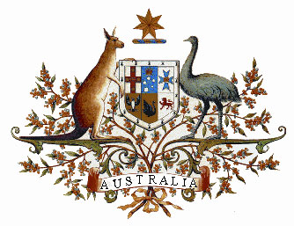
The new Australian nation was established on 1 January 1901 following the passing of the Commonwealth of Australia Constitution Act by the United Kingdom parliament. The purpose of the act was ‘to constitute the Commonwealth of Australia’. The Constitution drawn up at the conventions was included as part of this Act, which declared that ‘The Constitution of the Commonwealth shall be as follows: - …’.

What does the Constitution do?
Australia is a federation of States which each have their own constitution, government and laws. The Australian Constitution originated as an agreement under which the former colonies came together as States in a federation. In brief, the Constitution establishes the form of the federal government (that is, the Commonwealth, national or central government) and sets out the basis for relations between the Commonwealth and the States.

Features of the Australian Constitution
The Australian Constitution is a written constitution and is divided into eight chapters and 128 sections. It sets out the basis for Australia’s federal system of governance, the key features of which include:
- A federal parliament and government, responsible for national decision-making and law-making.
- A bicameral Parliament, including the Queen (represented by the Governor-General), the Senate and the House of Representatives.
- Six state governments, responsible for state matters.
- Power-sharing arrangements between the federal and state parliaments.
- The High Court of Australia, which is the final court of appeal. The High Court interprets the Constitution and decides its meaning, as well as, settling disputes between the federal and state governments.
The Constitution does not cover all aspects of the governance of Australia. For example, the Prime Minister and the Cabinet are not mentioned in the Constitution.

Chapters of the Australian Constitution
Chapter and description | Area of Focus
Chapter 1-the Parliament | Describes the composition and powers of our federal Parliament, which consists of the Queen and a bicameral legislature.
Chapter 2-the Executive Government | Describes the power of the most formal elements of Executive Government, including the Queen, Governor-General and the Federal Executive Council.
Chapter 3-the judicature | Provides for the creation of federal courts, including the High Court of Australia.
Chapter 4-finance and trade | Deals with finance and trade matters.
Chapter 5-the states | Outlines the federal relationship between the Commonwealth, and the states and territories. Outlines how federal law overrides state law. Gives the federal Parliament the power to override a territory law.
Chapter 6-new states | Deals with the creation of new states and gives the Commonwealth power to make laws for the government and representation of the territories.
Chapter 7-miscellaneous | Describes where the capital of Australia should be and the power of the Governor-General to appoint deputies.
Chapter 8-alteration of the Constitution | Describes how the Constitution can be changed by referendum.



What is a constitution?

What act was passed in order for the Australian Constitution to come into effect?

How many chapters and sections are in the Australian Constitution?
Chapters:
Sections:

List 5 features of the Australian Constitution

List each chapter of the Australian Constitution and include its description.

